H-1B modernization

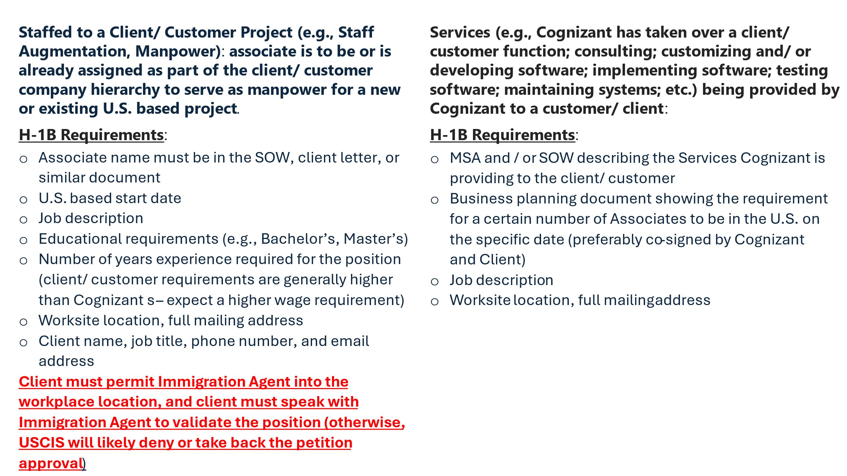

Position Information

Managers, responding to below questions is mandatory. Please respond to every question fully and truthfully. Any misrepresentation of the information and/or facts could result in disciplinary action up to and including termination of employment.

- What work has Cognizant contracted to provide to the customer (please specify either):
- Staff Aug – Manpower, OR
- IT - Consulting services

- If Cognizant is contracted to provide services to the customer, please provide a description of the services in layman’s language.

- Will the nominated associate be supervised by a Cognizant Manager for all their day-to-day activities? (Yes / NO)

- Will the nominated associate receive any work instruction on day-to-day activities directly from the client(s)? (Yes / NO)

- Is there a confirmed U.S. position for the nominated associate? (Yes / NO)

- Please provide the start date and end date of the nominated associate’s role in the project:
- Start Date: (MM/DD/YYYY)
- End Date: (MM/DD/YYYY)

- Will the nominated associate have any other ongoing U.S. projects with different clients at the same time? (Yes/No). If yes. Provide, Client name. Location, Start and end date.

- Please provide nominated associate’s primary roles and responsibility on this U.S. project.

- Will the nominated associate work as part of a Cognizant team at the same worksite location? If so, how many other Cognizant associates are on the same project at the same worksite location?

- If the nominated associate will undergo training from the client (Yes/No). If “Yes” please provide the list of training(s).

Manager Letter Guideline

GUIDANCE/ INSTRUCTIONS FOR U.S. BASED HIRING OR NOMINATING MANAGER/ HCM MANAGER FOR ASSOCIATES OR CANDIDATES BEING ASSIGNED TO A CLIENT ACCOUNT FOR WHICH COGNIZANT IS PROVIDING SERVICES (THIS DOCUMENT IS NOT TO BE USED FOR ROLES INVOLVING STAFF AUGMENTATION/ STAFFED TO A CLIENT PROJECT ROLE)

- You must provide true, accurate and correct information.
- Whether working at a Cognizant office/ RDC, Home office, or onsite in the U.S. at a client location, every H-1B associate must always: (1) receive assignments and be supervised directly by a Cognizant US based manager regardless of whether it is HCM manager or other Cognizant more senior subject matter expert (M band/ grade or above) who then updates the HCM manager on the H-1B associate’s duties/progress; and (2) use Cognizant tools, methods, platforms, frameworks or Cognizant body of knowledge/ best practice to do his/ her work.
- Associates sponsored for visa status should never receive or otherwise procure contracts (MSA, SOW, etc.) or client letters for the petition filing on their behalf.
- The HCM Hiring Manager takes ownership of obtaining approval and authorization from the U.S. based account manager that there is an in-fact U.S. assignment for the associate or candidate as of the date of nomination, supported by a business planning document to be provided to GM.
- Please provide description of the job duties using the addendum for technical roles.
- The following table provides the framework of Cognizant’s Band/ Grade mapping and H-1B program sponsorship. MOST IMPORTANTLY, if the role and responsibilities exceed or are less than what is specified for the nominated candidate/associate, please escalate to the onsite Global Mobility team:
Education & Experience Cognizant Job Requirement | Band/ Grade | Level of Responsibility: if the associate has more than the required experience that is not relevant to the role since the job itself requires the education and experience specified in the first column.
Bachelor’s in field related to the job, 2 years experience | Senior Associate | Qualified level position: requires a good understanding of the job duties/ job requirement. Senior Associates perform moderately complex tasks that require limited judgment. Managerial responsibilities/ tasks, team lead responsibilities are NOT permitted.
Bachelor’s or Master’s in field related to the work, 3 years experience | Manager | Experienced level position: requires a sound understanding of the job duties/ job requirements. Uses independent judgment and coordinate and/ or supervise other Cognizant associates.
Bachelor’s or Master’s in field related to the work, 4+ | Senior Manager and Above | Competent level position: requires sufficient understanding of the job duties/ job requirements to plan and conduct work using independent judgment. Senior Managers and above use advanced skills to solve unusual and complex problems. They may manage and/ or supervise Cognizant associates.

- IF THE TEMPLATED LANGUAGE DOES NOT MATCH YOUR ROLE AS IT RELATES TO THE ASSOCIATE, PLEASE ESCALATE TO THE GLOBAL MOBILITY TEAM LEAD.


February/03/2025

United States Citizenship and Immigration Services
USCIS Service Center

Re: Karthik Bhaskaran

Dear Officer:

I offer this letter to detail the conditions of the direct, full-time, 40 hour per week employment of Karthik Bhaskaran in conjunction with Cognizant’s H-1B petition filing.

Work Activities

Mr. Karthik Bhaskaran work activities will include:

 | Job Duties | Percentage of Time
1 | He would be responsible for study of the existing system and come up with  optimized technical solution for new business requirement. This includes study of  existing system architecture, technology usages, application functionalities,  hardware usages, possibility of incorporation of Cloud services (Microsoft Azure), use of DevOPS tools, GenAI Automation, use of Cognizant tools, process & methodologies to finalize system requirement for proposed solution.  He will demonstrate proposed solution to Business Line and get required sign-off.  On Business sign-off, create design document having low level technical changes,  test strategy, different team involvement, data flow to internal or external  applications, technology requirement etc. Give design document walkthrough to  all stake holders and get sign-off after applying all review comments. | 20
2 | He wound be responsible for end-to-end development activities which includes  creation of technical specification, build of software using Mainframe/ Azure/ DevOPS/GIT related technologies, creation of unit test plan, write of script to automate manual testing, test of software using automated or manual test script, promote of software package to Integration & User Acceptance test region, fix of any bug identified during testing, creation of package for implementation, raise of change request, implementation of tested software package in production region, validate implementation, perform live execution, support queries from technical/business team, fix any bug/defect identified post implementation etc.  He would be also responsible to make sure Functional and non-Functional tester  understand business expectation and covering all scenarios to achieve business goal, address queries from client, use of appropriate tools in development, unit testing and implementation phases | 45
3 | He would be responsible for analysis of existing manual business process to find  out automated solution. This includes capture of existing manual business process,  brainstorming with Business, SME and Cognizant offshore/onshore resources to  find out expected solution that can be developed. Selection of Cognizant tool,  process & methodologies that can be used for solution. Creation of solution  document and demonstration of solution to Business Line, SME and other  stakeholders. | 20
4 | He will participate in different Agile ceremonies like Sprint Planning, Sprint  Retrospective, Sprint Refinement, Sprint review and Sprint Demo on Weekly/bi-weekly basis. Estimate the story points during Sprint Planning and discuss on the  items which did not went well and to be improved as part of Sprint retrospective.  From Cognizant, represent scrum teams during Agile Ceremonies and share the key information to key stakeholders. Demonstration of new functional solution/system functionality to Business Line during System demo meeting. | 10
5 | He will use the Cobol Code Coverage and Cobol Standard Checklist Tool  developed by Cognizant to validate and ensure the quality of the software code  meets the coding standard. Customize Cognizant Cobol Coverage and Cobol  Standard Checklist tool to meet expected coding standard. This includes addition  of new rule or deactivation of existing rule from the tool before quality check. | 5
 | TOTAL | 100

As detailed above, Karthik Bhaskaran will use advanced and complex theories and methods related to the Cognizant position, and the Cognizant position requires a minimum a bachelor’s degree in a field of study that is directly related to position to successfully perform the job duties.
The below organization charts are specific to the assignment which Mr. Karthik Bhaskaran has been selected for in the U.S.:

US Bancrop

Selection of Employees and Control of Work

At all times, Cognizant remains the sole and direct employer of our talent and has control over the work of its employees. It is Cognizant that selects which of its employees will conduct work activities, determines what activities those employees will perform, and directly supervises and controls the work of those employees. At all times, Cognizant is responsible for paying salaries, benefits, and expenses for those employees. In the course of controlling the work activities of employees, Cognizant managers use a multitude of communication media and tools to supervise and control the work of our employees, including in-person or via video conferencing, desktop video, VoIP, mobile phones, instant messaging tools as well as through Cognizant’s systems and tools.

Performance Reviews

The Performance Management Process at Cognizant is a structured, formal interaction between an employee and his or her manager. This process includes evaluating performance against set objectives and competencies applicable for that role, providing performance feedback, identifying development needs, and setting goals for the future. This on-going performance communication takes place between the employee and that employee’s manager, which results in a performance rating for the employee. The objective of the Performance Management Process is to fuel the success of Cognizant and its employees.

Please feel free to contact me for additional information. Thank you.

Sincerely,

Sathish Babu Jayavelu
Project Manager
+1331-226-4243
sathishbabu.jayavelu@cognizant.com

